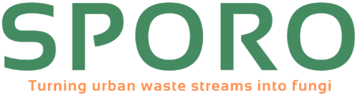
Waste? No way!
Sporo’s mission is to turn local and urban waste streams into new nutrition to grow fungi on!

Turning waste into high quality substrate
Locally, socially and ecologically
Innovative technology
Low energy consumption and CO2 reduction
Contribute to a circular economy

At SPORO, we produce local and circular substrate for functional mushrooms such as lion's mane, oyster and shiitake mushrooms. From Rotterdam, we process urban waste streams such as coffee grounds and brewers' grains into high-quality substrate. To do this on a larger scale, we are setting up a substrate factory where we will further optimize our substrate production by means of a unique energy-efficient sterilization method and by developing specific substrate formulas for the different types of mushrooms. This allows us to close local cycles, reduce CO2 emissions, and create a scalable solution for urban organic waste streams to prevent waste incineration and raw material waste. Thanks to our specialized substrate recipes and scaled-up production, we can guarantee consistent quality at competitive prices and with minimal waste. In this way, we are leading the way toward a more sustainable system for mushroom production!

